NORTH CENTRAL REGION
2022-2025
REGIONAL QUALITY IMPROVEMENT PLAN
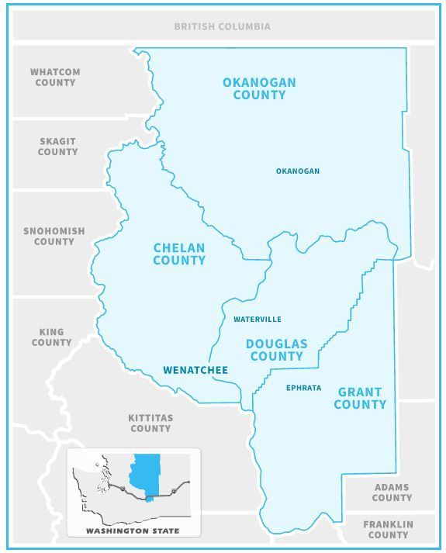
MISSION STATEMENT
The North Central Region Quality Improvement
Committee strives to optimize Emergency Systems
of Care through a collaborative multidisciplinary
approach to improve patient outcomes.
Collaborative Support Provided by North Central Emergency Care Council
Proudly Serving Chelan, Douglas, Grant, and Okanogan Counties
http://www.ncecc.org/
1.800.346.4032

NORTH CENTRAL REGION QUALITY IMPROVEMENT PLAN
Mission Statement
The North Central Region Quality Improvement Committee strives to optimize Emergency Systems of Care through a collaborative multidisciplinary approach to improve patient outcomes.

- Authority: As described in WAC 246-976-910(2): Levels I, II, III, IV, V adult and Levels I, II, and III, pediatric trauma care facilities shall establish, coordinate, and participate in regional EMS/TC systems quality improvement programs.

As described in RCW 70.168150 2(a) and 2(b), all designated cardiac/stroke centers will participate in associated regional QI activities. This will take place and follow the process of the already established EMS/TC systems quality improvement program.

- Purpose and Scope: To optimize Emergency Systems of Care through a collaborative multidisciplinary approach and to improve patient outcomes using goal focused, data driven quality improvement.

- Structure
  - Meeting Components
    - Frequency: Quarterly, 2 hours in length
    - Review State and Regional Data/trends and ad hoc reports as requested by the department, regional council, or QI committee
    - Review of Injury Prevention data/trends
    - Review regional PCPs as needed

    - Trauma, Cardiac, Stroke, and EMS Systems Updates
    - Educational opportunity discussion as guided by case review or regional QI data/trends
    - Focused Confidential Case Review to
    - include the following and kept confidential per RCW 70.168.090 and 42.56:
      - Continuum of care from dispatch through rehabilitation
      - Providers involved in care may be present, or available for questions and discussion
      - Audio-visual Aids
      - Issues identified
      - Lessons learned
      - Educational opportunity discussion

  - Audit Filters for Focused Case Reviews will be as follows:
      - Trauma:
        - Double Transfers
        - Patients who bypass the closest designated trauma center
        - Delays in patient transport either from the scene or transferring between facilities (greater than 3 hours for transfers OUT)

      - Cardiac:
        - Door-in-door-out (DIDO) > 30 minutes
        - Patient transferred for Primary PCI: FMC to Reperfusion > 120mins
          - Per regional STEMI protocol: For STEMI patients at non- PCI capable hospitals, if FMC to CWH arrival will be greater than 60mins and there are no contraindications, give fibrinolytic therapy per protocol.
        - Door to Fibrinolytics > 30 minutes
      - Stroke:
        - Double transfers

        - Door to tPA time > 60 minutes and Door in Door Out (DIDO) greater than 120 minutes to Primary or Comprehensive Stroke Center
        - Door to tPA time >45 minutes and DIDO >120 minutes to Comprehensive or Primary Stroke Center

      - Prehospital:
        - Trauma:
          - Scene time delays % of greater than 10 minutes based on DOH Trauma Triage Guidelines
          - Patients with GCS <8 without an airway placed
            - ETT
            - Supra/retro glottic airway
        - Patients without spinal motion restriction placed despite mechanism
        - Appropriate utilization of Air Medical resource per NC Regional PCP/County Operating Procedures
        - MCI events that involve Emergency Management response

      - Rehabilitation
        - % of patients discharged from rehab to home

    - Next QI Committee meeting goals and targets

- Goals: North Central Regional Quality Improvement Councils goals to improve regional care are:
  - Identify patterns and trends of our Regional Emergency Systems of care through accurate and timely data collection.
    - Prehospital, transport and hospital-based care will be included to emphasize a regional approach to the QI process.
  - Analysis of trends and patterns of Regional Emergency Systems of Care
    - Assess Patient Flow Patterns
      - Patient flow patterns, interfacility transports and methods of transport will be evaluated to identify trends and patterns.
      - Outcomes will be compared to similar agencies/healthcare facilities within the region, state, and nationally. Goals may be developed to establish a benchmark regardless of institutional status.
      - Individual cases of care will be examined to highlight trends or patterns through case review with specific focus on area for change or improvement.
  - Review of state and regional data trends
    - The state Trauma Registry, Cardiac and Stroke registries, as well as other emergency systems shall provide routine summary reports as appropriate and distributed to with the agenda in advance. Reports will be standardized, emphasizing the state and regional trauma, cardiac and stroke systems. Data will relate to case presentations selected by committee representatives.
    - Information regarding regional injury prevention data or trends shall report any issues/filters that will assist in focused performance improvement.
  - Loop Closure
    - NCRQI will report trends and patterns of the regional systems of care to the North Central Emergency Care Council or other appropriate agency.
    - Opportunities for improvement will be made to appropriate agencies with recommendations for process improvement.
    - Cases sent to the QI committee review and recommendation require follow up with feedback and recommendations or action taken.

- Reporting
  - The Chairperson is responsible for providing summary conclusions of discussions. Provisions must be provided for feedback to the Department of Health and the Regional Counsel regarding identified EMS and facility issues and concerns.

- Membership
  - Minimum membership is maintained in accordance with the standards set forth in WAC 246-976-910(3)
  - Chairperson and 2 vice Chairs
    - 2 Year position elected by most voting members. Positions must be held by a required member of the QI Committee.
  - Voting Members:
    - Medical Directors from each designated trauma facility and/or designated trauma rehabilitation center
    - County Medical Program Directors
    - Nurse Coordinators/Program Managers from the Emergency Systems of Care for each of the designated facility and/or rehabilitation centers
    - EMS Provider Representative elected from each local council
    - Regional EMS Council Chair
    - Regional Injury Prevention Representative for Peds and Adults
    - Air Medical Services Representative (2)
*Any of the above members may be replaced by an official designee from the represented facility or agency.
  - Non-Voting Members
    - Emergency Department Directors (clinical and medical)
    - *Critical Care Department Directors (clinical and medical)
    - State DOH staff
    - *Medical Specialists as needed and determined by chairperson
    - Non-designated facility representatives
    - *County Coroner/Medical Examiner
    - County EMS Director
    - County Dispatch center representative
    - Regional Council Staff
*As appropriate for QA purposes.
e. Quorum: A quorum shall consist of a minimum of 10 voting members at the beginning of the meeting and will continue if 6 voting members remain.

- Confidentiality
  - Actions of the QI Committee are confidential as provided in WAC 246-976-910(5)(e)(f)(g)(h) and protected by RCW 43.70.510 and chapters 18.71, 18.73, and 70.168.
  - Confidentiality: All attendees of the QI meeting will sign a pledge of confidentiality which will also serve as a record of attendance.
  - All members of the QI Committee and those who have been invited to attend by members of the committee have access to view or discuss case information. It is the obligation of the attendees to keep all information confidential and to protect it against unauthorized intrusion, corruption, or damage.

- Documentation
Minutes: Minutes from the QI Committee meeting will be prepared by a designated recorder and will be reviewed and approved by the members of the committee. One permanent copy will be kept for the purposes of the record and maintained by the North Central Regional EMS & Trauma office.

ATTACHEMENT A

North Central Region Quality Improvement Plan TEMPLATE FOR CASE REVIEWS
I. NCRQI Case Review
- Name of presenter
- Name of agencies represented
- Date
II. Topic
- Question or issue to be addressed with this case review
- Scene/Background Information
- EMS Findings/Interventions
- Description of Pt
- Vital Signs
- Interventions
V. ED Interventions/Findings
- Vital Signs
- Interventions
- Findings
- Injury List
- Consults
- Pt Disposition
VI. Hospital Course
- Length of Stay
- Surgeries
- Other Injuries/Procedures Done
- Cost
- Rehab (if appropriate)
- Outcome
- Discharge Status
- Current Update on Pt Outcome

ATTACHMENT B
North Central Region Quality Improvement Plan
I have received and reviewed a copy of the North Central Regional Trauma Quality Improvement Plan.
Cascade Medical Center
Medical
Voting Member Director
Program
Voting Member Manager
Central Washington Hospital
Medical
Voting Member Director
Program
Voting Member Manager
Chelan/Douglas County MPD
Voting Member MPD
Columbia Basin Hospital
Medical
Voting Member Director
Program
Voting Member Manager
Coulee Medical Center
Medical
Voting Member Director
Voting Member Program
Manager
North Valley Hospital
Medical
Voting Member Director
Program
Voting Member Manager
Chelan Health
Program
Voting Member Manager

Mid-Valley Hospital
Medical
Voting Member Director
Program
Voting Member Manager
Three Rivers Hospital
Medical
Voting Member Director
Program
Voting Member Manager
Okanogan County MPD
Voting Member MPD
Quincy Valley Medical Center
Medical
Voting Member Director
Program
Voting Member Manager
Samaritan Healthcare
Medical
Voting Member Director
Program
Voting Member Manager
Confluence Health Acute Rehabilitation
Rehab
Voting Member Rep
Okanogan County EMS Council Representative
Voting Member
Greater Wenatchee EMS Council Representative
Voting Member
Grant County EMS Council Representative
Voting Member
North Central EMS Council Chair
Voting Member

North Central Region Injury Prevention Representative
Voting Member

